Bryan Guner 9/23/15

**Matlab Assignment #1**

**1.1.2:**

>> A=zeros(6,1)

A =

0

0

0

0

0

0

>> B=linspace(325,405,4)

B =

325.0000 351.6667 378.3333 405.0000

>> a=sum(B)

a =

1460

**1.2.2:**

>> a=[5,3,1];b=[1,3,5];c=a+b

c =

6 6 6

>> a=[5,3,1];b=[1,3,5];c=a-b

c =

4 0 -4

>> c=a.*b

c =

5 9 5

>> c=a./b

c =

5.0000 1.0000 0.2000

>> a.^2

ans =

25 9 1

>> d=[1 2 3;4 5 6;7 8 9];d(1,:),d(:,2)

ans =

1 2 3

ans =

2

5

8

**1.3.2:**

**graph of x vs. y for theta and time #1**

>>t1=0:0.1:9;

>> t2=0:0.1:8;

>> g=9.8;

>> vox=50;

>> voy=100;

>> theta1=(5*pi/12-0.255);

>> theta2=(5*pi/12-0.425);

>> y=voy*sin(theta1).*t1-0.5*g*t1.^2;

>> x=vox*cos(theta1).*t1;

>>

>> figure;

>> plot(x,y);

>> title('x(t) vs. y(t)');

>> xlabel('time(s)')

>> xlabel('range')

>> xlabel('range(m)')

>> ylabel('altitude(m)')

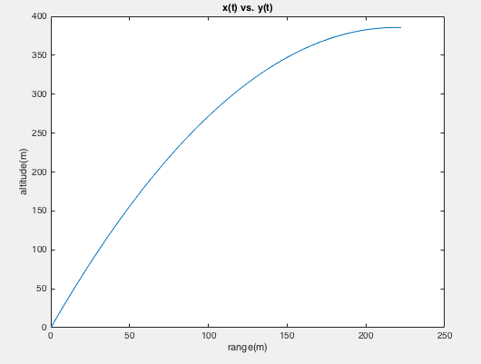

**Graph of x vs. y for theta and time #2**

>>y=voy*sin(theta2).*t2-0.5*g*t2.^2

>> x=vox*cos(theta2).*t2;

>> figure;

>> plot(x,y);

>> title('x(t) vs. y(t)');

>> figure;

>> plot(x,y);

>> title('x(t) vs. y(t)');

>> xlabel('Range');

>> ylabel('Altitude');

>> xlabel('Range(m)');

>> ylabel('Altitude(m)');

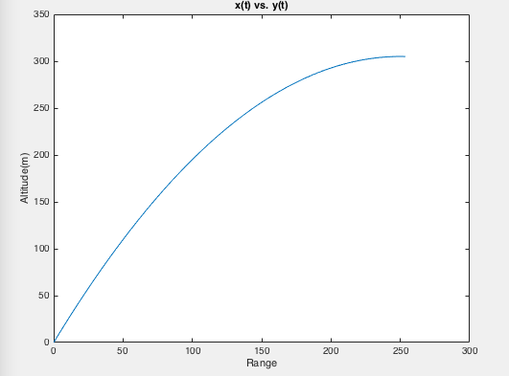

Theta2 has a larger projectile range